Add User in your LMS Course

Teacher role can add/enrol new users and remove/unenrol existing users from his/ her LMS course.
- Login to LMS and open your course.
- Click on the “Actions Menu” icon available in the top right of the course page. Click on the link “More” from the dropdown menu.

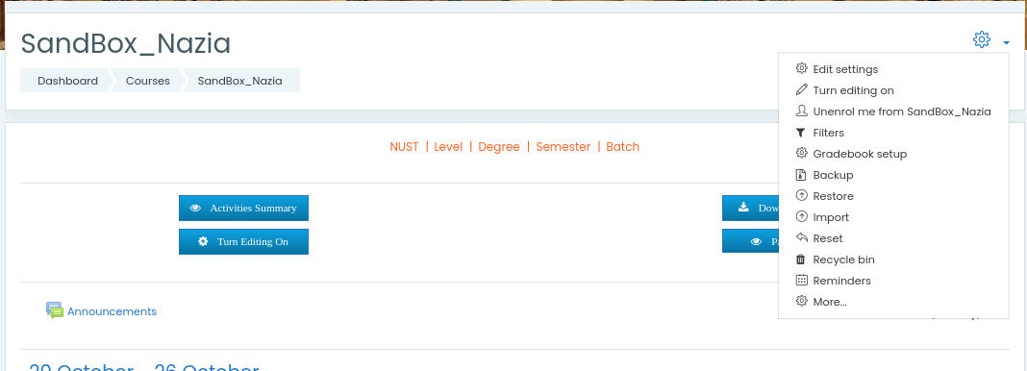

- Select the “Users” tab and click on the link “Enrolment methods”.

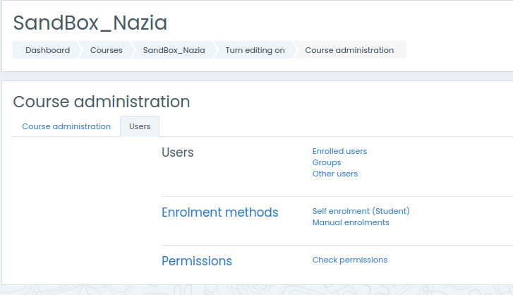

- All enrollment methods in the course are displayed. For manual enrollment/ unenrollment of any user, click on the icon of “Enrol users” available in the row of “Manual Enrollments” i.e 2nd last icon from right side.

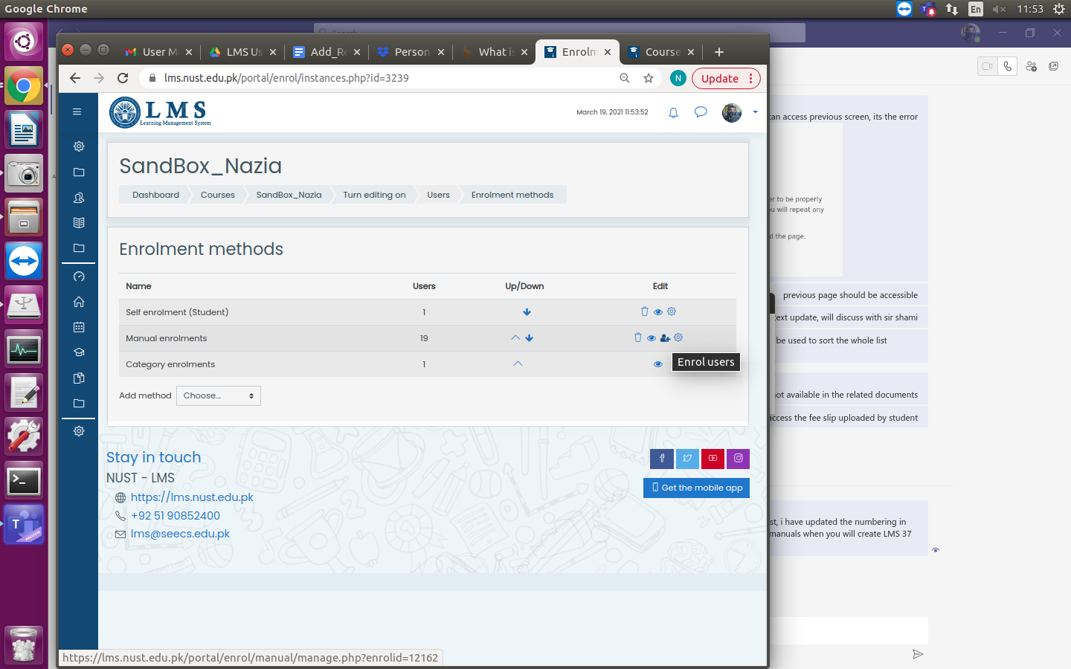

- Search LMS user id of the user in the search field of “Not enrolled users” (i.e. Right side panel). Select the user and click on the “Add” button to enroll the user in course.
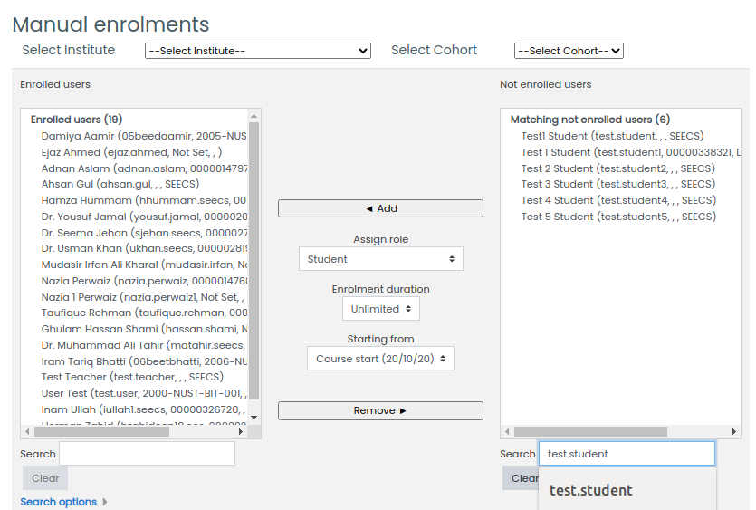
- Any existing user can be removed by selecting the user from “Enrolled users” list and and clicking the button “Remove”.





